**List of GI registered products in Uttar Pradesh**

1. **Varanasi Wooden Lacquerware & Toys**

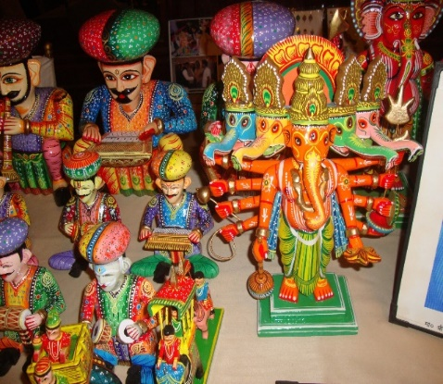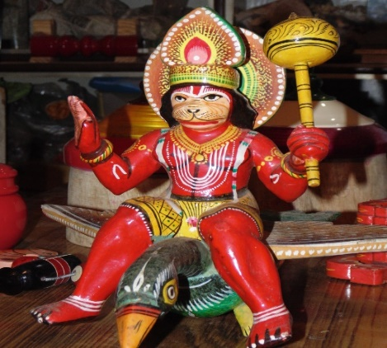

1. ***GI Registration Number:*** *457* ***(https://search.ipindia.gov.in/GIRPublic/Application/Details/457)***
2. ***Location :*** Kashimiriganj, Khojawan, Kirahaiya, Lahartara, Ramnagar of Varanasi district
3. ***No. of GI Authorised Users:*** *95*
4. ***Product Description:***

Varanasi Wooden Lacquerware & Toys, for their unique aesthetic sense, are used for a variety of occasions and moods – as simple toys for children to marriages. This craft is popular across the world. Traditionally made by Kunder Kharadi Samaj and Vishwakarma community in the city area like Kashimiriganj, Khojawan, Kirahaiya, Lahartara, Ramnagar and rural areas. It encompasses various type of traditional motifs and designs in products such as wooden mask, figure of God & Goddess, flying styles, different type of faces, Sindurdani, variety of Latoos (spinning tops), flower pots, dolls, decorative items etc. It is based on lacquerware and painting techniques. Nearly 2500 artisans are involved in this craft

**2. Benaras Metal Repousse**

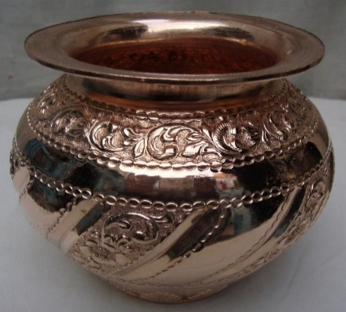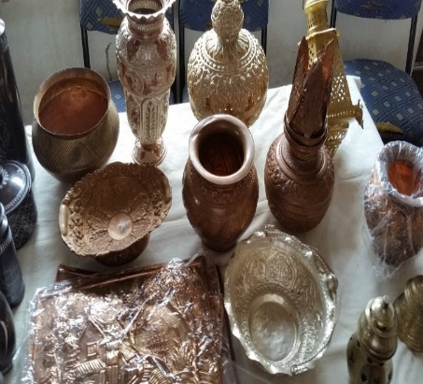

1. ***GI Registration Number:*** *398* ***(https://search.ipindia.gov.in/GIRPublic/Application/Details/398)***
2. ***Location :*** Kashipura, Nichi Bagh and Ram Ghat of Varanasi district
3. ***No. of GI Authorised Users: 61***
4. ***Product Description:***

Metal Repousse craft by traditional Kasera community in Varanasi is popular from Vedic period to the modern era. The unique technique is sometimes referred to as 'chasing' or embossing (Khal - Ubhar Ka Kaam). This art form is still preserved in the lanes (gali) of old Varanasi since generations. Through this craft various artifacts such as faces of God & Goddess, Gold and Silver dresses, traditional ornaments etc, are done. This craft is also used to decorate the doors and walls of temples and in making various type of gold and silver utensils based on repoussé technique. In the Mahakumbh Mela- Rath, Singhasan, Hauda, Chhatra, Chawar, Dand and various such type of products are available that are made by Banaras metal artisans. Nearly 500 metal artisans are still working and few are popular in the country for their exclusive works at important temples like Shree Kashi Vishwanath Temple, Golden Temple at Amritsar, Tarn Taarn Gurudwara, Jain temple at Shravanbelgola and many more in the country.

**3. Banaras Gulabi Meenakari Craft**

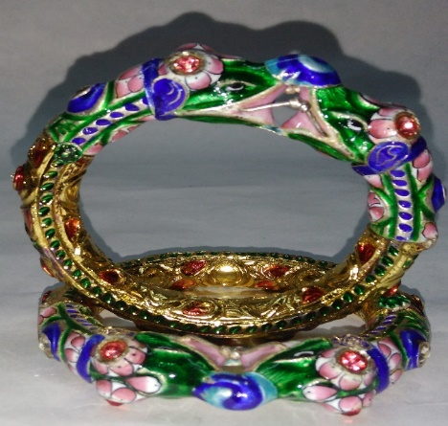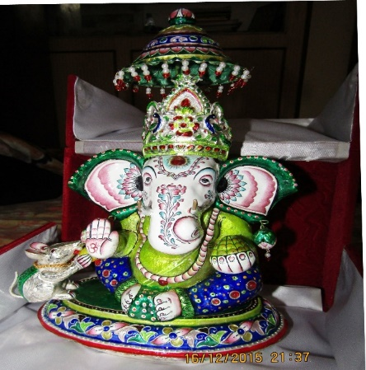

1. ***GI Registration Number:*** *397*

***(https://search.ipindia.gov.in/GIRPublic/Application/Details/397)***

1. ***Location :*** *Varanasi*
2. ***No. of GI Authorised Users:*** *30*
3. ***Product Description:***

The Gulabi Meenakari (Pink Enameling) in Varanasi is characterized by its unique pink strokes on white enamel. The motifs have lotus blooms and buds. Around 200 artisans are working in this age old traditional craft at the older parts of Varanasi city. Banaras Gulabi Meenakari was very much popular in the ancient time. It is still in demand. Currently, a few manufacturers also make Banaras Gulabi Meenakari on silver and gold. This craft is directly linked with the precious Kundan Jewelleries.

**4. Varanasi Soft Stone Jaali Work**

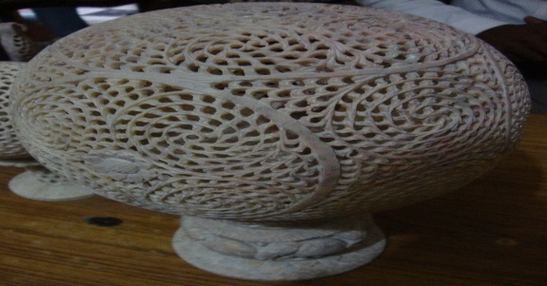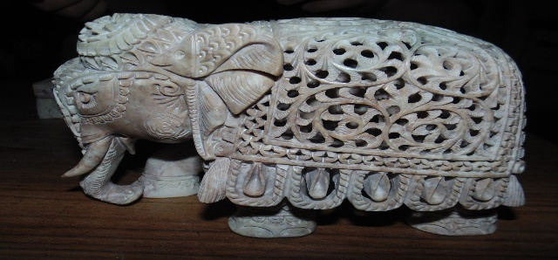

1. ***GI Registration Number:*** *556*

***(https://search.ipindia.gov.in/GIRPublic/Application/Details/556)***

1. ***Location:*** Ramnagar of Varanasi district
2. ***No. of GI Authorised Users:*** *172*
3. ***Product Description:***

The Varanasi artisans of soft stone craft are famous for making beautiful Jali with undercut technique. One of the most popular art form includes 'Elephant within the Elephant' and it symbolises a unique human skill because the entire piece comes without any joints. The artisans make various types of decorative crafts such as birds, animals, balls, statues with a variety of carving work and that embodies traditional motifs in Jaali. Its unique quality is represented mainly by jaali crafts without any joint (i.e. in a single piece of stone). The base material of this stone craft is found in Khoria and Gorara regions of Uttar Pradesh. The stone called Anguri stone from Jhansi & Mahoba districts is also used. Mishir Pokhra, Luxa, Lahartara and Sarnath areas of Varanasi city are the important locations for the soft stone Jaali (undercut) work.

**5. Banaras Zardozi**

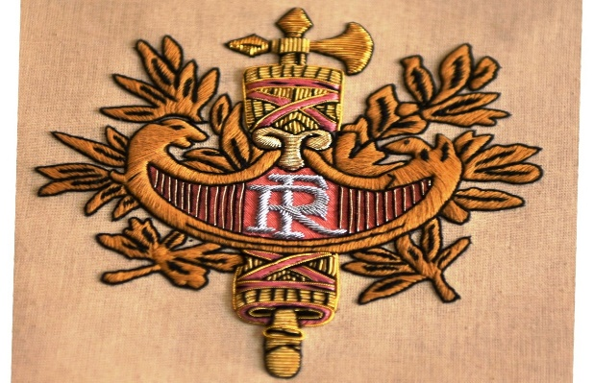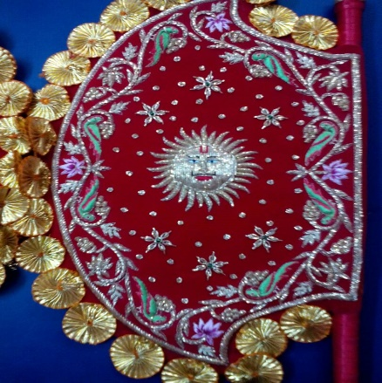

1. ***GI Registration Number:*** *620*

***(https://search.ipindia.gov.in/GIRPublic/Application/Details/620)***

1. ***Location :*** Varanasi
2. ***No. of GI Authorised Users:*** 151
3. ***Product Description:***

Zari or thread of gold is woven into fabrics usually silk or velvet to create intricate patterns. The thread is also used as a raw material for Zardozi embroidery, which is one of the oldest and most beautiful embroidery styles of Varanasi. It is used extensively in clothing and lavish decorations. The Zardozi artisans make intricate bespoke book covers, military badges, flags, robes of leaders and attires donned by Murtis. Heavy Zardozi curtain known as Pichhoi can be few meters in size and often used as backdrops of idols in temples and thrones.

**6. Banaras Wood Carving**

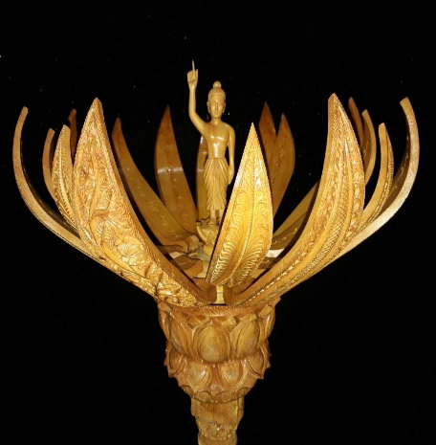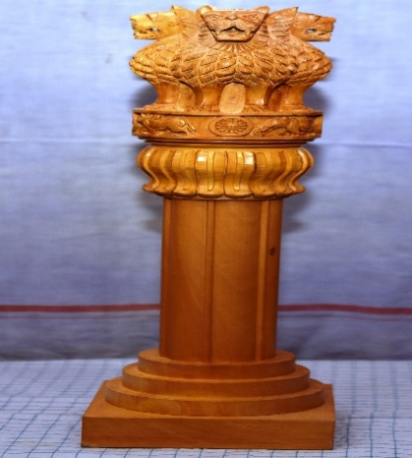

1. ***GI Registration Number:*** *623*

***(https://search.ipindia.gov.in/GIRPublic/Application/Details/623)***

1. ***Location :*** *Varanasi*
2. ***No. of GI Authorised Users:*** *94*
3. ***Product Description:***

Banaras Wood Carving relates to the time of Ivory works of Varanasi and then shifted to Sandal wood carving. But after both materials were put under protected category, the artisans shifted to Kaima wood. Varanasi features a style combining wood carving and metal repoussé work with the use of Silver, Copper and Brass for making different type of Thrones, Chairs, Door Frames, Doors panels, Wall plates and Howda of Elephants. These craftsmen have been making these handicrafts over generations and pass on this skill to next generation of their family. The toys have a rural touch and depict village landscape, bullock carts, village people or cooking vessels.

**7. Banaras Hand Block Print**

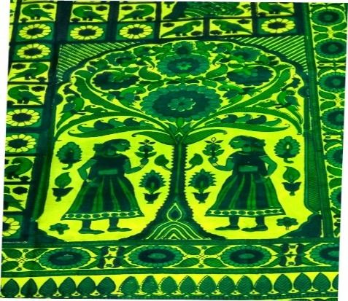 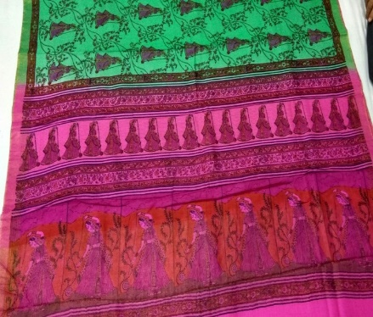

1. ***GI Registration Number:*** *624*

***(https://search.ipindia.gov.in/GIRPublic/Application/Details/624)***

1. ***Location:*** *Varanasi*
2. ***No. of GI Authorised Users:*** *40*
3. ***Product Description:***

Varanasi is famous for extremely fine hand block printing work on silk fabrics, silk sarees. Blocks or Bunta are made of seasoned teak wood by trained craftsmen and the master artisans also give training to the younger generation in the block making process. Varanasi artisans also use very fine brass blocks for fine work and traditional motifs. Block printed Silk scarves are very popular in Japan, Korea, Europe as well as in the Gulf countries. There is very good connection of block printing and silk weaving in Varanasi. The weavers weave plain silk sarees and then the hand block printers use multi-colour fine motifs for printing on it.

**8. Banaras Langda Aam (Mango)**

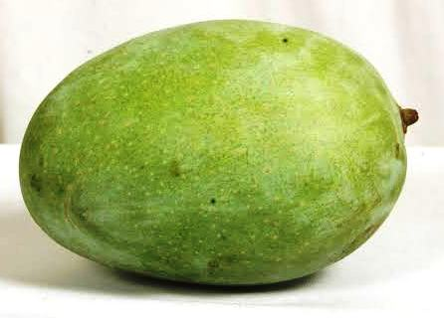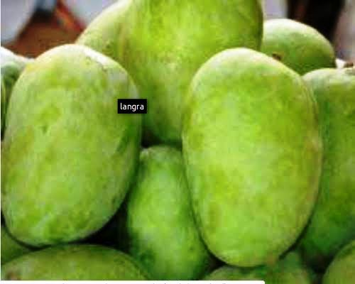

1. ***GI Registration Number:*** *716*

***(https://search.ipindia.gov.in/GIRPublic/Application/Details/716)***

1. ***Location :***Varanasi
2. ***No. of GI Authorised Users:*** *Recently Registered, as of now they are in the process.*
3. ***Product Description:***

Banaras Langda Mango is known for its unique taste, size, colour and fragrance. It has several uniqueness:

* Highest pulp to stone ratio
* Fruits are sweet and fleshy.
* Maintains its green color after ripening
* Good source of vitamin A, C and E and Iron
* Helps in maintenance of appropriate cholesterol level, skin cleansing, alkalizing body, increase virility in men, improve eye sight, aids good digestion, prevents heat stroke, strengthening immune system

**9. Banaras Pan (Betel Leaf)**

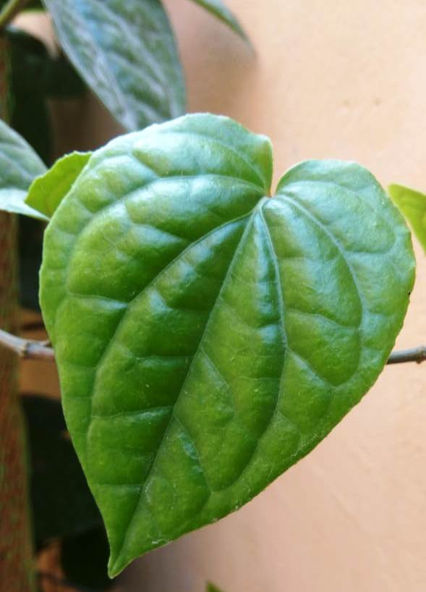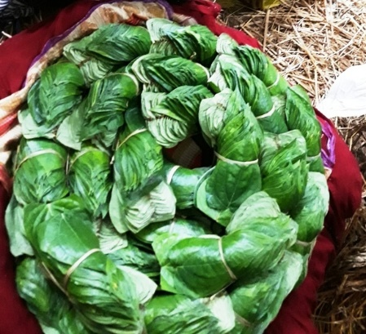

1. ***GI Registration Number:*** *730*

***(https://search.ipindia.gov.in/GIRPublic/Application/Details/730)***

1. ***Location :*** *Varanasi*
2. ***No. of GI Authorised Users:*** *Recently Registered, as of now they are in the process.*
3. ***Product Description:***

Varanasi is famous for its Banarasi Pan and it is mentioned in various historical books, articles and gazetteers. The Betel Leaf from Varanasi and nearby districts has many unique characteristics which include:

* Contains phytochemicals and antioxidants
* It has properties to act like anti-amoebic, anti-inflammatory, anti-fungal, anti-microbial etc.
* It can also cure bad breath, boils and abscesses, conjunctivitis, constipation, headache, hysteria, itches, mastitis, mastoiditis, ringworm, swelling of gum, rheumatism, abrasion and cuts.
* It has a number of applications in pharmaceutical and cosmetic industry

**10. Ramnagar Bhanta (Brinjal)**

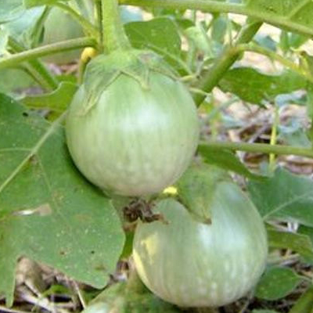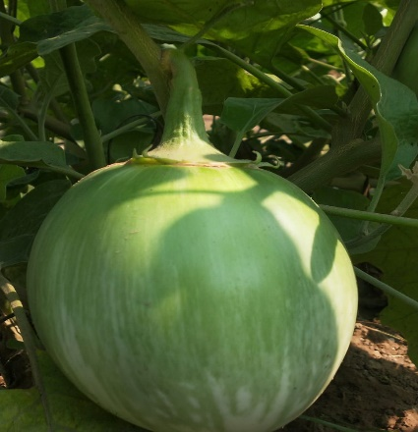

1. ***GI Registration Number:*** *717*

***(https://search.ipindia.gov.in/GIRPublic/Application/Details/717)***

1. ***Location :*** *Varanasi*
2. ***No. of GI Authorised Users:*** *Recently Registered, as of now they are in the process.*
3. ***Product Description:***

Ramnagar Bhanta is an indigenous variety of Brinjal grown in and around Ramnagar in Varanasi. It has several distinct features which include:

* The Fruit is Round in shape and the size of the fruit grows during fog in the Winter Season
* It has very less calories and is rich in soluble fiber content
* It is also rich in bioflavonoids which help in controlling blood pressure and reducing stress
* It also contains many essential B-complex group of Vitamins and antioxidants
* It is also a good source of essential minerals

**11. Muzaffarnagar Gur (Jaggery)**

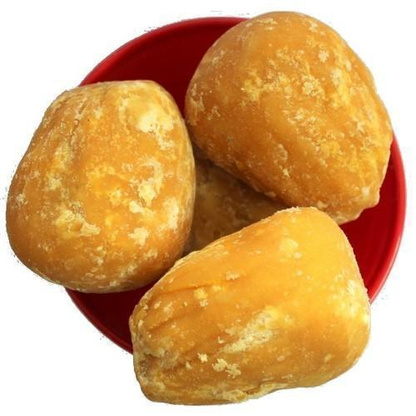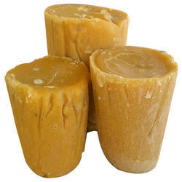

1. ***GI Registration Number:*** *723*

***(https://search.ipindia.gov.in/GIRPublic/Application/Details/723)***

1. ***Location:***
2. ***No. of GI Authorised Users:*** *Recently Registered, as of now they are in the process.*

***d. Product Description:***

Muzaffarnagar Gur (Jaggery) is the most ancient sweetening agent manufactured in in India. Muzaffarnagar Gur is a pure, traditional, unrefined form of sweetener. It is a good source of minerals like Calcium, Iron, Phosphorous and Protein. Muzaffarnagar Gur is a processed form of concentrated sugarcane juice processed as golden yellow colour product. Jaggery/Gur is produced in different shapes and sizes at Muzaffarnagar in UP, like Basket, Laddoo, Pansera, Chaquoo, Khurpa, Ruscutt, Desi Shakkar (powder Jaggery/Gur) and many more.

**12.** **Mirzapur Handmade Dari**

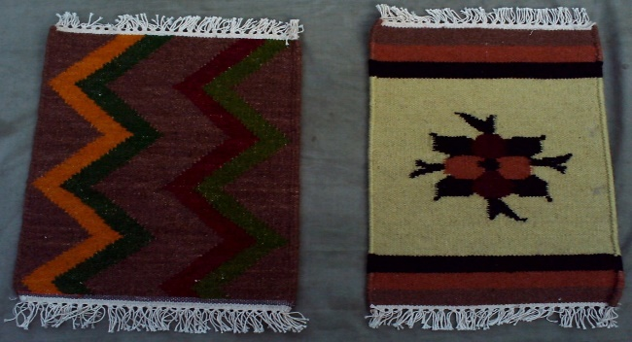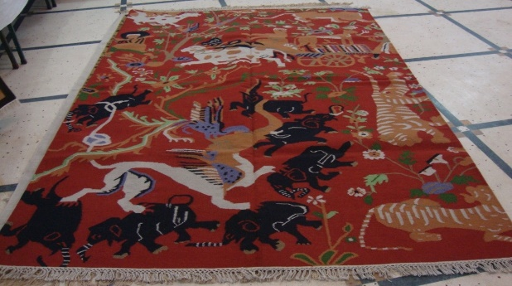

1. ***GI Registration Number: 458***

***(https://search.ipindia.gov.in/GIRPublic/Application/Details/458)***

***b. Location: Mirzapur***

***c. No. of GI Authorised Users:297***

***d. Product Description:***

*Dari* making process of this region is older than Mughal period and initially the artisans were making it for their own use and for the domestic market for floor covering. The *Panja Dari* has received global recognition because of its unique traditional motifs, weaving technique of *Iron Punja* and color combination in a natural manner. Shilp Guru Award has awarded to a local Mirzapur Dari weavers including National Award winner are from Mirzapur.

**13. Nizamabad Black Clay Pottery**

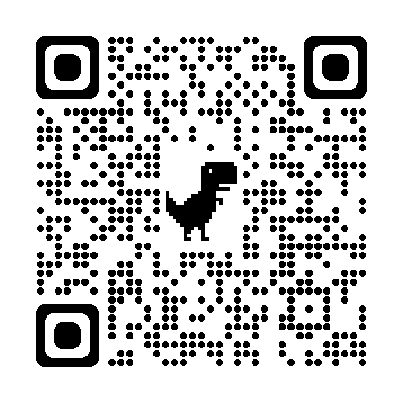

1. ***GI Registration Number: 459***

***(https://search.ipindia.gov.in/GIRPublic/Application/Details/459)***

***b. Location :*** Azamgarh and Mau

***c. No. of GI Authorised Users: 41***

***d. Product Description:***

Nizamabad Black Pottery is very exclusive for its unique characteristics. Nizamabad in the Azamgarh district of Uttar Pradesh is famous for its Black pottery for over 100 years. The potter uses local soil for making various shapes. The most important process is using the furnace for baking different type of pots several times in a traditional way. The artistry of black pottery is reflected in a variety of traditional motifs and designs. It comes in different type of shapes that are made basically on the potter wheel followed by finishing with needles and silver filigree work. Nearly 250 families are directly involved in this craft. Many national and state awardees from this age-old craft are making export oriented products since generations with their unique skill.

**14.** **Ghazipur Wall-hanging**

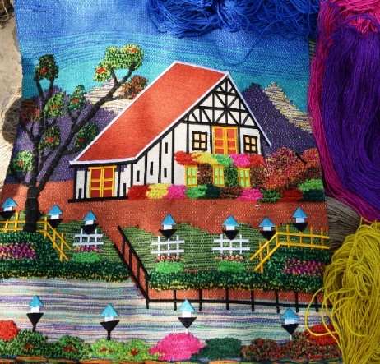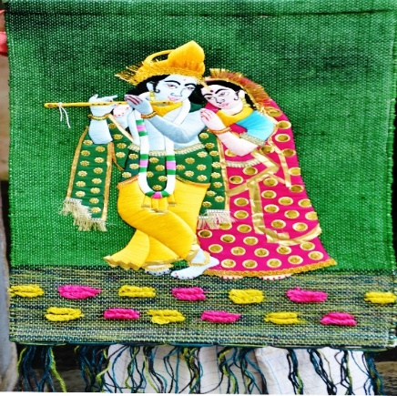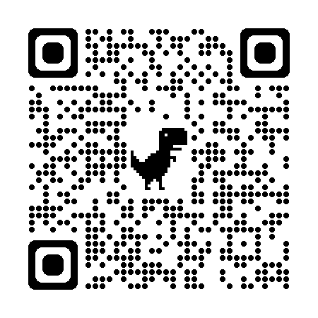

1. ***GI Registration Number: 555***

***(https://search.ipindia.gov.in/GIRPublic/Application/Details/555)***

***b. Location:*** Devkali and Saidpur blocks of Ghazipur

***c. No. of GI Authorised Users: 147***

***d. Product Description:***

It’s a unique type of handmade craft that uses 3 different type of technique *viz.* Hand-woven in pit loom (without Jacquard), Rapping with embroidery and Pasting work in finished product. They carry thousands of types of designs, motifs and pattern in many colours and natural fibers. The major production area is Devkali and Saidpur blocks of Ghazipur, Varanasi, Chandauli and Mirzapur districts of Uttar Pradesh. This is an original weaving technique without jacquard and done with the help of simple sketch diagrams. The artisans use many colors and their creativity is reflected in using the appropriate colour at appropriate place making each product unique. Nearly 4000 artisans are involved in the production process with a good number of woman artisans. About 10 exporters from Varanasi are involved in export of various decorative products and traditional items.

**15. Chunar Sand Patthar (Stone)**

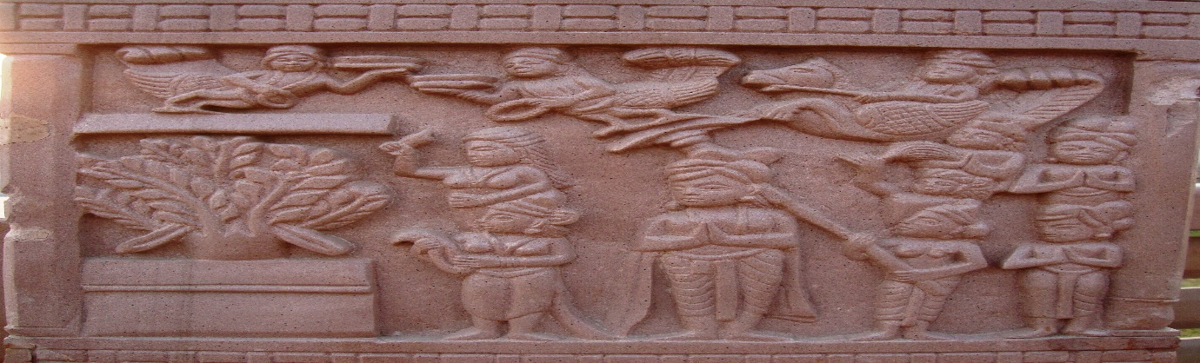

1. ***GI Registration Number: 557***

***(https://search.ipindia.gov.in/GIRPublic/Application/Details/557)***

***b. Location :*** Mirzapur , Chandauli, Sonebhadra

***c. No. of GI Authorised Users: 15***

***d. Product Description:***

Bhartihari, the ruler of ancient Ujjain, who came to Varanasi for penance and built a grand fort with Chunar Sand Stone on the banks of holy river Ganga, is a classic example of human skill with its own uniqueness. The National Emblem of India - the "Ashoka Chakra" taken from Ashoka Pillar of Sarnath, which is made out of Chunar Sand Stone, is a unique example of their strength, quality and composition from beginning of 250 BC.

**16. Mirzapur Pital Bartan (Utensil)**

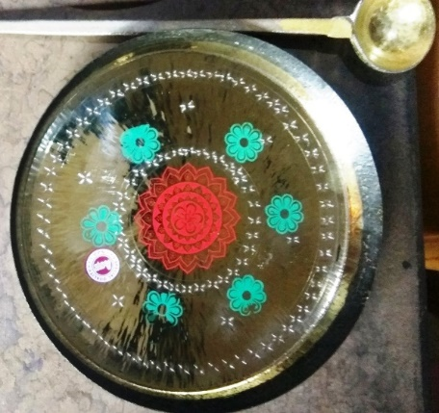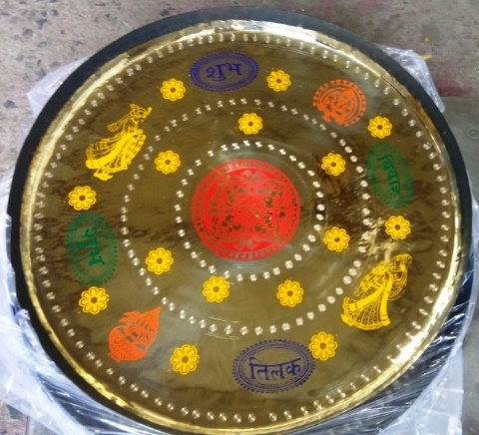

1. ***GI Registration Number:*** *622*

***(https://search.ipindia.gov.in/GIRPublic/Application/Details/622)***

*b.* ***Location:*** Mirzapur

***c. No. of GI Authorised Users:*** *13*

***d. Product Description:***

Mirzapur is one of the most important centres of the brass Utensil industry in Uttar Pradesh. The quality of the soils is most favourable for the moulds, as its neither cracks nor melts. The work of metal refinement is called “Niyara” in local dialect. It means choosing a particle of non-ferrous from waste material of non-ferrous. Mirzapur brassware industry is a located in the city and its workers come from the city and the surrounding villages. At present, the manufacturing units of Brassware by and large are linked with the local dealers who place order with them and buy their products when offered for sale. Various products are being manufactured and this activity is also included under ODOP.

**17. Chunar Glaze Pottery**

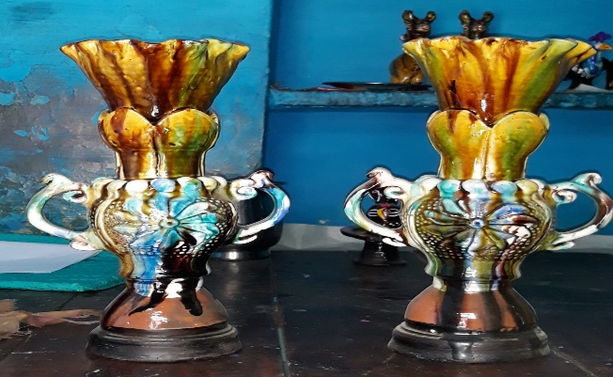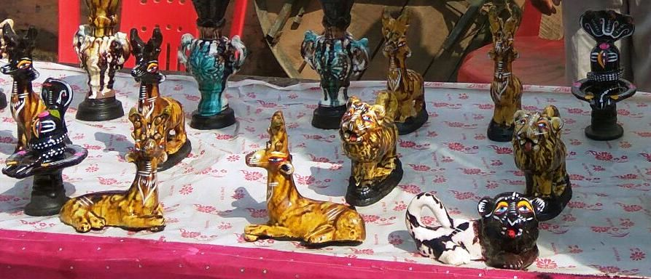

1. ***GI Registration Number: 621***

***(https://search.ipindia.gov.in/GIRPublic/Application/Details/621)***

***b. Location :***Mirzapur

***c. No. of GI Authorised Users: 59***

***d. Product Description:***

Chunar, a small town in Mirzapur District of Uttar Pradesh, is known for its decorative Red Clay pottery. This pottery contains delicate designs made with silver paint. A more elaborate variety is by producing a glossy finish using a special powdery preparation called ‘kabiz.’ This powder is made from soil taken from rice field. Chunar skills of making glazed terracotta artifacts using the Gangetic red clay dates back to the Mughal Period. After independence Govt. of U. P. set up a state pottery centre in 1953 to provide common service facilities to artisans at the location.

**18. Gorakhpur Terrocotta**

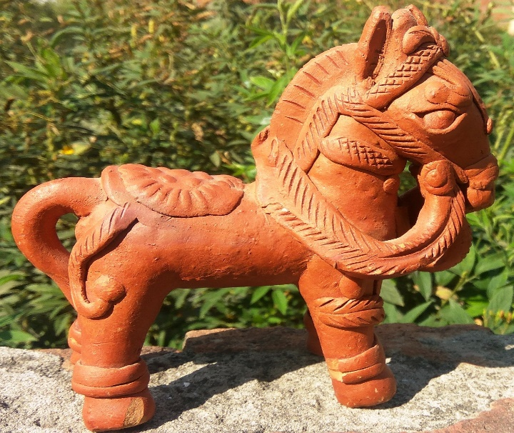

1. ***GI Registration Number: 619***

***(https://search.ipindia.gov.in/GIRPublic/Application/Details/619)***

***b.Location:*** Gorakhpur

***c. No. of GI Authorised Users: 157***

***d. Product Description:***

History of the teracotta art form is a traditional art form of lndia that has taken shape over thousand years ago. This art form in India has been flourishing since the age of Indus valley Civilization. The terracotta art is another form of clay art that has the variety of pottery, earthenware, bowls, cups, vases and figurines have been found (2600-1700 BC). Even from the Harappa and Mohenjadaro, various figures and figurines have been excavated.

**19**. **Aligarh Tala**

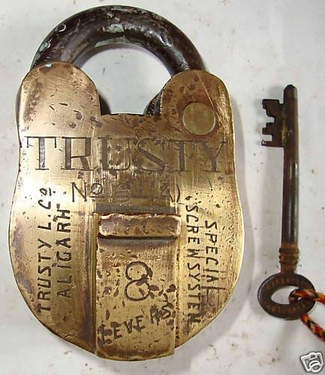 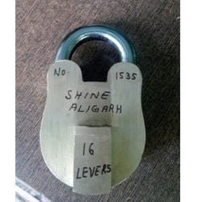

1. ***GI Registration Number: 664***

***(https://search.ipindia.gov.in/GIRPublic/Application/Details/664)***

***b. Location:***Aligarh

***c. No. of GI Authorised Users: 13***

***d. Product Description:***

Aligarh is known as city of lock for over 200 years. The first international firm established in Aligarh by the name Johnson & Company is mentioned in British Gazetteer of Aligarh,1926. The unique component of the locks made in Aligarh are brass and iron and made by hand. Aligarh Tala found mention way back in 1823 in newspaper called Agra Akhbar.

**20. Bakhira Brassware**

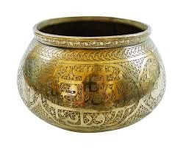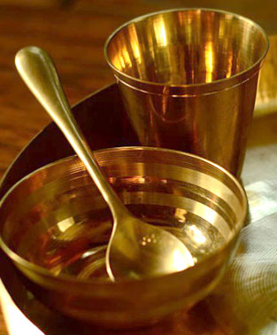

1. ***GI Registration Number: 665***

***(https://search.ipindia.gov.in/GIRPublic/Application/Details/665)***

***b. Location:***Sant Kabir Nagar

***c. No. of GI Authorised Users:*** *Recently Registered, as of now they are in the process.*

***d. Product Description:***

The bakhira brassware of Sant Kabir Nagar is an ancient craft. The artisans engaged in this craft make various types of artistic utensils and pieces such as bowls, plates, glasses, vessels, jug, vase, bells and more. Brass Handicrafts produced here are very popular world over and they represent the true Indian craftsmanship. These exclusive and elegantly crafted brassware is not only popular in national markets but are also in huge demand in international markets as well.

**21. Banda Shazar Pathar Craft**

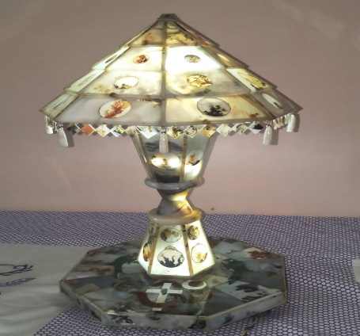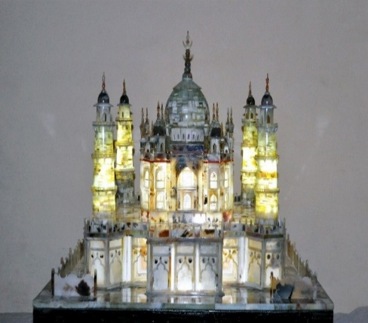

1. ***GI Registration Number:666***

***(https://search.ipindia.gov.in/GIRPublic/Application/Details/666)***

***b. Location:***Banda

***c. No. of GI Authorised Users:*** *Recently Registered, as of now they are in the process.*

***d. Product Description:***

Sazar is a Dendritic Agate belonging to the Chalcedony family with hardness of 7 Mohs'. It is a translucent to opaque stone characterized by inclusions of branch-like dendrites. Colours may be clear, white or whitish-gray, with black, brown or greenish brown dendrites. This stone is listed under the semi-precious gems category. The patterns we see on the sazar are either leeching of manganese or iron oxide probably along with waters containing silica in solution which percolates and deposited a siliceous gel in the interior of the rocks. It may also be entrapped fossils of fungus (basically algae). A fungus, which is entrapped between two or more pieces of sazar stone, produces either acid or base. This acid/base makes the stones translucent and acts as inorganic glue which coagulates the separate stones to one. The fossils of fungus left inside the stones looks like patterns of leaves or trees and add beauty to the stone.

**22. Nagina Wood Craft**

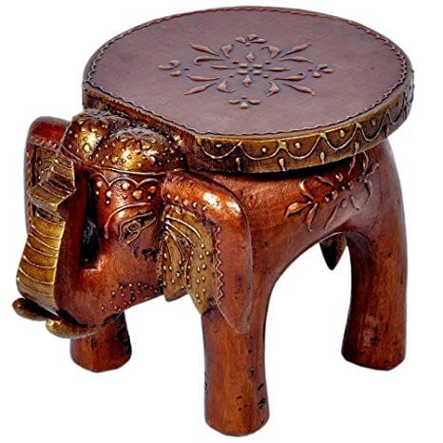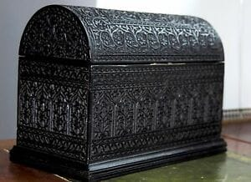 

1. ***GI Registration Number: 667***

***(https://search.ipindia.gov.in/GIRPublic/Application/Details/667)***

***b. Location:*** Bijnor

***c. No. of GI Authorised Users:*** *Recently Registered, as of now they are in the process.*

***d. Product Description:***

The history of wood crafts industry of Nagina is about 500 years old. The town is mostly inhabited by Multani people who originally hailed from Pakistan. The curious wooden items manufactured by these people have been admired from the Mughal period. Of the wooden item walking sticks, exclusive brass inlay and wooden inlay boxes and engravings are very popular.

**23. Pratapgarh Aonla**

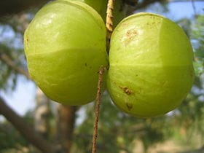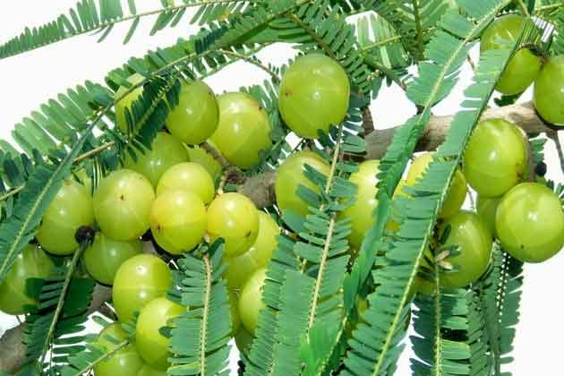

1. ***GI Registration Number: 668***

***(https://search.ipindia.gov.in/GIRPublic/Application/Details/668)***

***b. Location :*** Pratapgarh

***c. No. of GI Authorised Users:*** *Recently Registered, as of now they are in the process.*

***d. Product Description:***

A Nature’s wonder Amla is one of the precious gift of nature to mankind. Fruit known in Sanskrit as- Amalaka, Hindi- Amla. Amla is a rich source of vitamin C, among I gm of vitamin C per 100 ml fresh juice, and requisite for ihe synthesis of collagen, which is liable for keeping the cells of the body together. It has the same amount of vitamin C present in two oranges. It increases the red blood cell count and helps to promote good health. Numerous experimental evidences have shown that Aonla fruit possess antioxidant, hepatoprotective, hypocholesterolemic and anti-inflammatory activities.

**24. Hathras Hing**

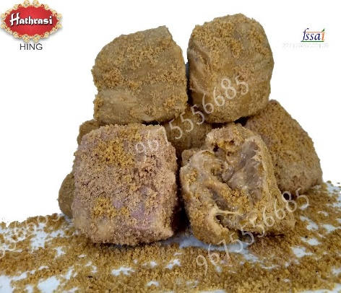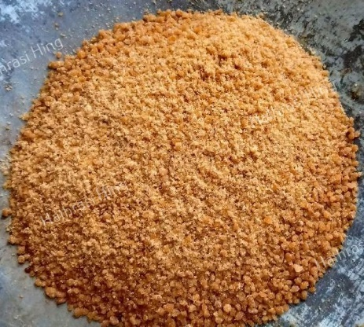

1. ***GI Registration Number: 672***

***(https://search.ipindia.gov.in/GIRPublic/Application/Details/672)***

***b. Location:*** Hathras

***c. No. of GI Authorised Users:*** *Recently Registered, as of now they are in the process.*

***d. Product Description:***

Hathras comes under the Brij region of Northern India and is famous for its Industrial, literary and cultural activities. According to Purans, Hathras can be of the age of Mahabharata. Hathras was an industrial hub during the British Raj. This spice is used as a digestive aid, in food as a condiment and in pickling. It plays a critical flavoring role in Indian vegetarian cuisine by acting as umami enhancer. In its pure form, it is sold in the form of chunks of resin, small quantities of which are scraped off for use.

**25. Adamchini Chawal**

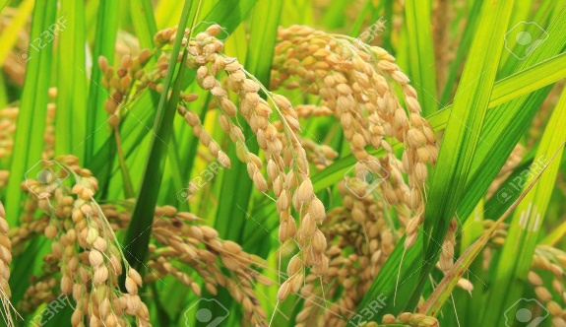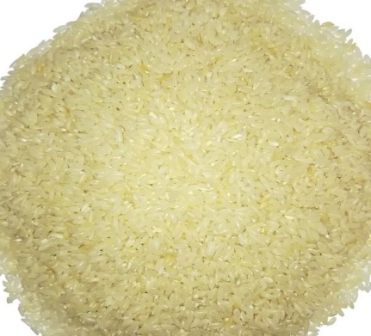

1. ***GI Registration Number: 715***

***(https://search.ipindia.gov.in/GIRPublic/Application/Details/715)***

***b. Location:*** Mirzapur, Chandauli, Varanasi and Sonbhadra

***c. No. of GI Authorised Users:*** *Recently Registered, as of now they are in the process.*

***d. Product Description:***

Mirzapur, Chandauli, Varanasi and Sonbhadra farmers grow rice variety Adamchini, which is one of the finest quality aromatic rice. Adamchini rice is believed to be the nature's gift to the Vindhya Region of Indo Gangatic plain. Adamchini Rice are long duration variety and farmers grow for domestic markets. Cultivation of this variety of rice is highly remunerative.